Wireshark shows CAN frame details by clicking extension pane as shown below.

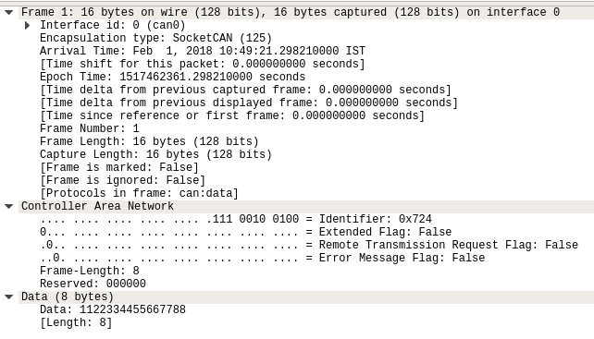

We have tried to send CAN frames by using **cansend** command.

1. **Frame 1 : Single Frame**

CAN header of Single frame details are displayed after Error Message Flag detail in Controller Area Network pane as shown below. Displaying CAN header details are same as for all block transfer frames.

For example, CAN payload of Single frame is 724#0122334455667788

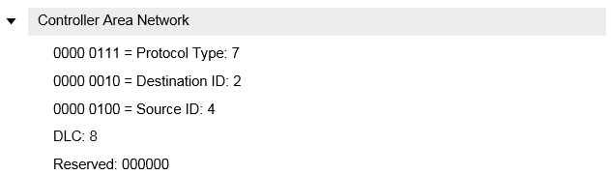

CAN payload of Single frame details are displayed in Data pane as shown below.

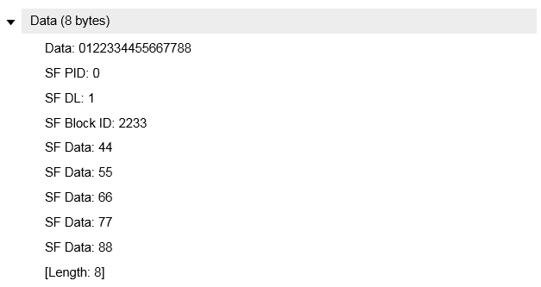

1. **Frame 2: First Frame-1**

CAN payload of First frame-1 details are displayed in Data pane as shown below.

For example, CAN payload of First frame-1 is 724#1122334455667788

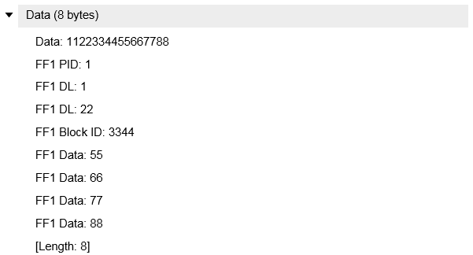

1. **Frame 3: First Frame-2**

CAN payload of First frame-2 details are displayed in Data pane as shown below.

For example, CAN payload of First frame-2 is 724#1000223344556677

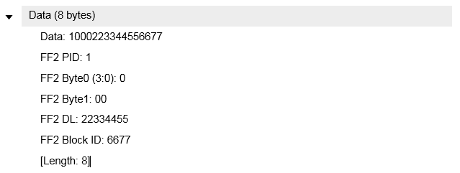

1. **Frame 4: Consecutive Frame**

CAN payload of Consecutive frame details are displayed in Data pane as shown below.

For example, CAN payload of Consecutive frame is 724#2233445566778899

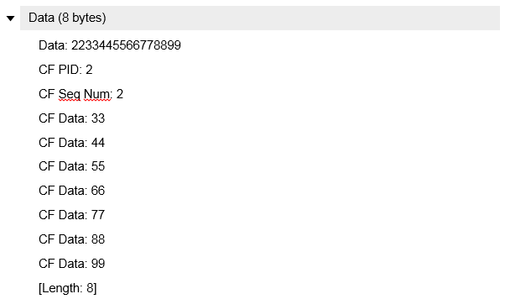

1. **Frame 5: Flow Control Frame**

CAN payload of Flow Control frame details are displayed in Data pane as shown below.

For example, CAN payload of Flow Control frame is 724#334455

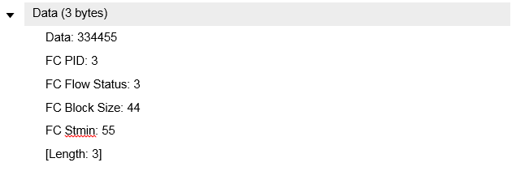

1. **Frame 6: Zeroconf MAC Defend Frame**

CAN header of Zeroconf MAC defend frame details are displayed after Error Message Flag detail in Controller Area Network pane as shown below.

For example, CAN payload of Zeroconf defend frame is 6F4#00

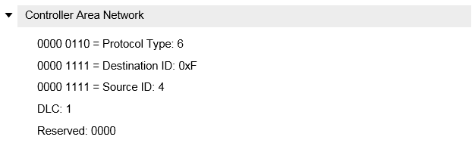

CAN payload of Zeroconf MAC defend frame details are displayed in Data pane as shown below.

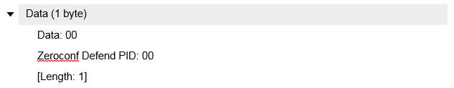

1. **Frame 7: Zeroconf MAC Claim Frame**

CAN header of Zeroconf MAC claim frame details are displayed after Error Message Flag detail in Controller Area Network pane as shown below.

For example, CAN payload of Zeroconf claim frame is 6FF#012233445566

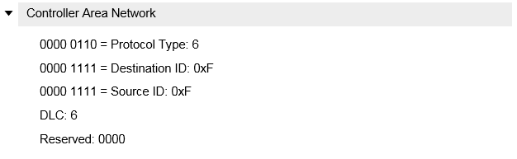

CAN payload of Zeroconf MAC claim frame details are displayed in Data pane as shown below.

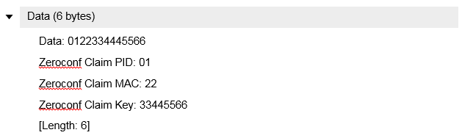

1. **Frame 8: CAN Echo Pong Frame**

CAN header of Echo Pong frame details are displayed after Error Message Flag detail in Controller Area Network pane as shown below.

For example, CAN payload of Echo Pong frame is 624#02

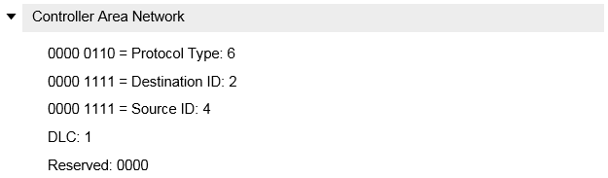

CAN payload of Echo Pong frame details are displayed in Data pane as shown below.

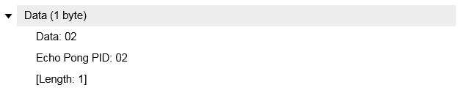

1. **Frame 9: CAN Echo Ping Frame**

CAN header of Echo Ping frame details are same as Echo Pong frame as captured above.

For example, CAN payload of Echo Ping frame is 624#03

CAN payload of Echo Ping frame details are displayed in Data pane as shown below.

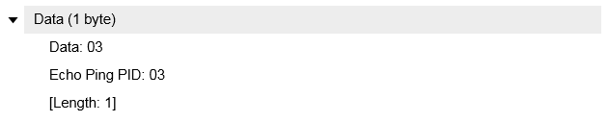

1. **Frame 10: Unused Frame**

CAN header of Unused frame details are same as Echo Pong frame as captured above.

For example, CAN payload of Unused frame is 624#06

CAN payload of Unused frame details are displayed in Data pane as shown below.

